# Date interpolation algorithm

### Purpose

Change the date steps in an image to a different date step. The output date step is usually selected from a fixed number of choices: 1-day, 8-day, 10-day, 16-day, month or year. A simple linear interpolation is used to calculate the new time series.

A user interface is available.

### Installation

Copy the nrs_timeseries.sav, the _nrs_menu.sav and the NRS_Utils.sav files into the save_add folder of ENVI, and (re)start ENVI. For detailed instructions see also [ENVI .sav files: Installation and configuration](http://www.itc.nl/personal/nieuwenh/installations.html)

### Running

Start ENVI. In the NRS | Timeseries menu select Time interpolation or type nrs_time_interpol_gui on the command line:

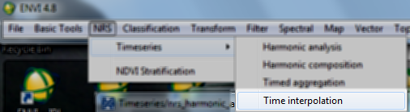

You will see the following interactive user interface:

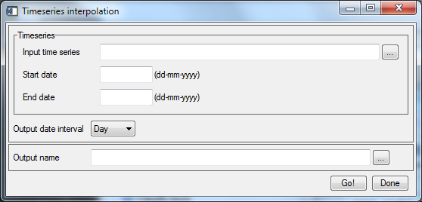

Where:

1. Input time series: Specifies a time series image stack.
2. Start date: The exact start date of the time series.
3. End date: The exact end date of the time series.
4. Output date interval: Select the output date interval from the combo box. The available options are: 'Day', '8-Day', '10-Day', '16-Day', 'Month' and 'Year'.
5. Output name: The name of the output time series; when the input is specified the software suggest a name for the new time series with a postfix (‘_tinp’).

Algorithm

The new date resolution is calculated with a simple linear interpolation:

$$v\left(t_{n}\right)=v\left(t_{i}\right)+\frac{v\left(t_{i+1}\right)-v(t_{i})}{t_{i+1}-t_{i}}×(t_{n}-t_{i})$$

Where:

tn = the new time position

ti = the last time position smaller than tn

ti+1 = the first old time position larger than tn

v(t) = the value at the time position

The old time range and step is calculated from the input time series and the start and end date specified.

Note: The interpolation only makes sense if the new time step is smaller than the input time step. It is however not prevented.